Smart StudyHub System

1. Introduction
The Smart StudyHub System is an educational platform designed to help university students collaborate and study together. The system connects students based on their academic field, year, and location, and provides intelligent study support through resource recommendations and quizzes. This document describes the functional and non-functional requirements of the system and serves as a reference for the development team throughout the software engineering lifecycle.

1.1 Purpose
The purpose of this SRS document is to define the requirements of the Smart StudyHub System clearly and completely. It is intended for use by the development team, project supervisors, and quality assurance personnel to ensure that all parties share a common understanding of the system's expected behaviour and scope.

1.2 Scope
The Smart StudyHub System is a web-based platform that allows students to:
- Create academic profiles with their specialization, year, and location.
- Find compatible study partners and groups through a smart matching engine.
- Access recommended study resources such as videos, summaries, and past exams.
- Take timed quizzes and view their ranking on a leaderboard.
- Communicate with group members and schedule study meetings.
The system does not include formal grading, integration with university LMS platforms, or native mobile applications in the initial release.

1.3 Definitions
SRS | Software Requirements Specification — a document describing the requirements of a software system.
Student | A registered user of the platform enrolled in an academic institution.
Admin | A privileged user responsible for managing platform content and user accounts.
Matching Engine | A system component that identifies compatible peers and groups based on student profiles.
Study Group | A group of students with shared academic interests formed through the platform.
Recommendation Engine | A component that suggests personalised study materials based on student data.
Quiz | A timed subject-specific assessment with a competitive leaderboard.
DFD | Data Flow Diagram — illustrates how data flows within the system.
UML | Unified Modelling Language — used to model and document software systems.

1.4 Overview
The Smart StudyHub System allows students to register, find study partners, join groups, access resources, and take quizzes — all in one platform. The system also provides administrators with tools to manage content, quizzes, and user accounts. The Context Diagram below shows the high-level interaction between the system and its external entities.

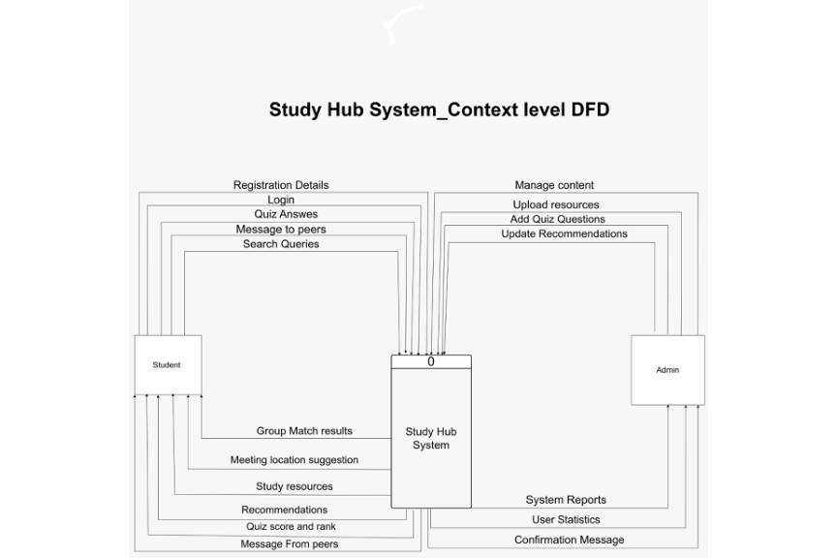
Figure 1.1 — Study Hub System: Context Level DFD
The diagram shows the system (Process 0) interacting with two external entities: the Student and the Admin. The Student provides registration details, login credentials, quiz answers, and search queries, and receives group matches, study resources, recommendations, quiz scores, and peer messages. The Admin manages content, uploads resources, adds quiz questions, and receives system reports and user statistics.

2. Overall Description

2.1 System Perspective
The Smart StudyHub System is a standalone web-based application. It consists of several components working together: a student profile module, a smart matching engine, a resource management module, a quiz engine, a communication module, and a meeting scheduler. These components are supported by a database layer and communicate through a RESTful API.

2.2 User Classes
The system serves two types of users:

Student: The primary user. Students register, manage their profiles, search for study partners, join groups, access study resources, take quizzes, and communicate with peers.

System Administrator (Admin): A privileged user who manages student accounts, uploads study resources, creates quiz questions, updates recommendations, and monitors platform activity.

2.3 Operating Environment
- Web browser-based application (Chrome, Firefox, Edge, Safari).
- Compatible with Windows, macOS, iOS, and Android devices.
- Hosted on a cloud server supporting HTTPS communication.
- Uses a relational database (e.g., MySQL or PostgreSQL) for data storage.
- Backend developed with a RESTful API architecture.

2.4 Assumptions and Constraints
Assumptions:
- Students provide accurate academic information during registration.
- All users have access to a device with a modern web browser and internet connection.
- Study resources uploaded by the Admin are properly licensed for educational use.

Constraints:
- The system must comply with applicable data protection regulations (e.g., GDPR).
- No direct integration with institutional LMS platforms in the initial release.
- Content moderation is performed manually by the Admin in the initial version.
- The system must support at least 500 concurrent users without performance issues.

3. User Requirements
This section lists the requirements as described by users in their own language.

Student Requirements:
- I want to create an account and enter my specialization, academic year, and city so the system can find suitable study partners for me.
- I want the system to suggest students in my same field and year so I can find study partners easily.
- I want to join study groups that match my subject so I can collaborate with other students.
- I want to receive recommendations for videos, summaries, and past exams relevant to my courses.
- I want to take timed quizzes and see how I rank compared to other students on a leaderboard.
- I want to chat with students in my group to discuss topics and share resources.
- I want to schedule study meetings with my group and receive reminders before the session.
- I want my profile to be private and my personal data to be secure.
- I want to update my profile information whenever my details change.

Admin Requirements:
- I want to upload and manage study resources (videos, PDFs, past exams) for students.
- I want to add and organise quiz questions by subject and difficulty.
- I want to view usage statistics and activity reports for the platform.
- I want to manage student accounts, including deactivating accounts that violate policies.

4. Functional Requirements
This section lists the functional requirements of the Smart StudyHub System in ranked order. A minimum of five functional requirements are described below. Note that Add, Edit, and Delete operations are not considered standalone functional requirements.

FR-01: Student Registration and Authentication
Description / Action: The system allows new users to register an account by providing personal and academic information. The system validates inputs, creates a student profile, and allows registered users to log in securely.
Requirements / Inputs: Full name, email address, password, academic specialization, academic year, and city/location.
Source: Student (via the registration and login forms).
Pre-condition: The student does not already have an account with the provided email address.
Post-condition: A new student profile is created in the database. The student is directed to their personalised dashboard upon login.
Output: A confirmation message upon successful registration. An error message if the email is already registered or if inputs are invalid.

FR-02: Smart Student Matching
Description / Action: The system analyses the student's profile and uses the Matching Engine to recommend academically compatible peers and study groups based on specialization, academic year, and location.
Requirements / Inputs: Student's specialization, academic year, and location (retrieved from the student profile).
Source: Student profile data stored in the database.
Pre-condition: The student must be logged in. At least one other compatible student profile must exist in the database.
Post-condition: A ranked list of compatible peers is generated and displayed to the student.
Output: A list of recommended study partners showing name, specialization, year, and location. A message indicating no matches were found if no compatible profiles exist.

FR-03: Study Group Recommendation and Management
Description / Action: The system recommends existing study groups that match the student's profile. The student can request to join a group. The system updates group membership and notifies the Matching Engine accordingly.
Requirements / Inputs: Student profile data; student's group selection (studentId, groupId).
Source: Student (via group recommendation interface); Groups Database.
Pre-condition: The student must be logged in and not already a member of the selected group.
Post-condition: The student is added to the group in the database. Group communication becomes accessible to the new member.
Output: A list of recommended groups. A confirmation message upon successful joining. An error message if the request fails.

FR-04: Quiz and Timer System
Description / Action: The system provides timed subject-specific quizzes. Upon starting, the system retrieves questions from the Quiz Bank, starts a countdown timer, evaluates submitted answers, computes a score, and updates the leaderboard.
Requirements / Inputs: Student's subject selection; quiz answers submitted within the time limit.
Source: Student (via quiz interface); Quiz Bank database.
Pre-condition: The student must be logged in. The selected subject must have at least five questions in the Quiz Bank.
Post-condition: The quiz score is stored. The leaderboard is updated to reflect the new submission.
Output: A countdown timer during the quiz. Final score and percentage upon completion. Updated leaderboard showing the student's ranking.

FR-05: AI-Based Study Resource Recommendations
Description / Action: The system uses the Recommendation Engine to generate personalised study material suggestions based on the student's profile, quiz performance, and activity history.
Requirements / Inputs: Student's profile data, quiz history, and resource access history.
Source: Student profile data; Resources Database; Recommendations Database.
Pre-condition: The student must be logged in. At least one relevant resource must exist in the database.
Post-condition: A personalised list of recommended resources is generated and displayed on the student's dashboard.
Output: A curated list of resources categorised by type (video, summary, past exam) with title, subject, and upload date.

FR-06: Group Communication
Description / Action: The system provides a real-time messaging feature within each study group, allowing members to exchange messages and share resource links.
Requirements / Inputs: Student identity; group membership verification; message content.
Source: Student (via group chat interface); Groups Database.
Pre-condition: The student must be logged in and an active member of the group.
Post-condition: The message is delivered to all active group members and stored in the group's message log.
Output: Real-time chat interface with message thread, timestamps, and sender names. Notification alerts for offline group members.

5. Non-Functional Requirements
This section describes the quality attributes that the Smart StudyHub System must satisfy. These requirements define how the system performs rather than what it does.

Performance
- The system must respond to standard user requests within 3 seconds under normal load.
- The Matching Engine must generate recommendations within 5 seconds.
- Quiz question delivery and answer evaluation must complete within 1 second.

Security
- Authentication must use secure token-based sessions (e.g., JWT) with a 24-hour expiry.
- The system must validate all inputs server-side to prevent injection attacks.
- Role-based access control must restrict administrative features from student users.

Reliability
- The system must maintain an uptime of at least 99.5% per month.
- Automated daily backups must be maintained with a recovery point objective of 24 hours.
Usability
- A new student must be able to complete registration and access core features within 10 minutes without external guidance.
- The interface must be fully responsive across desktop and mobile screen sizes.
Compatibility
- The system must be compatible with all major modern browsers (Chrome, Firefox, Edge, Safari).
- The platform must function correctly on Windows, macOS, iOS, and Android devices.

Availability
- The system must be available 24/7, with planned maintenance not exceeding 4 hours per month.
- Maintenance windows must be announced to users at least 48 hours in advance.

6. UML Diagrams
This section presents the UML and DFD diagrams developed for the Smart StudyHub System. Each diagram is accompanied by an explanation of its purpose, components, and contribution to the system design.

6.1 Use Case Diagram
The Use Case Diagram identifies the system's actors and their interactions with the available use cases. It defines the functional scope of the Smart StudyHub System from the user's perspective.

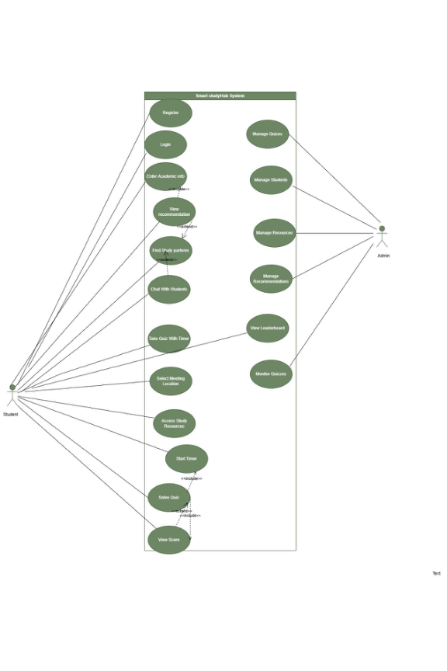
Figure 6.1.1 — Smart StudyHub System: Full Use Case Diagram

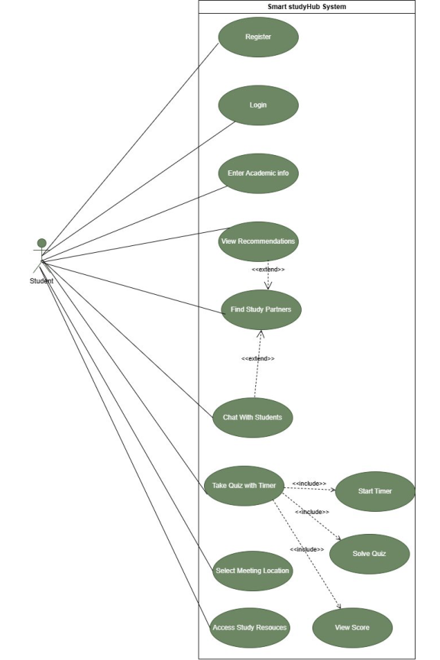
Figure 6.1.2 — Student Actor: Use Cases

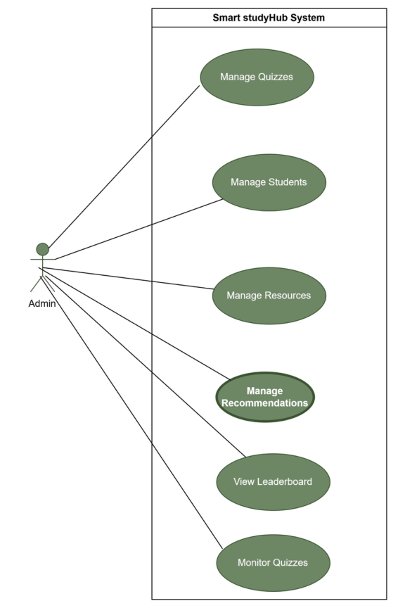
Figure 6.1.3 — Admin Actor: Use Cases

Two actors are identified: the Student and the Admin. The Student interacts with use cases including Register, Login, Enter Academic Info, View Recommendations, Find Study Partners, Chat With Students, Take Quiz With Timer (which includes Start Timer and Solve Quiz), Select Meeting Location, and Access Study Resources. The Admin manages Quizzes, Students, Resources, and Recommendations, and can View the Leaderboard and Monitor Quizzes. Include and extend relationships are used to capture mandatory sub-behaviours and optional extensions respectively.

6.2 Sequence Diagram
Sequence Diagrams illustrate the chronological interactions between system components for specific scenarios. Three primary workflows are modelled below.

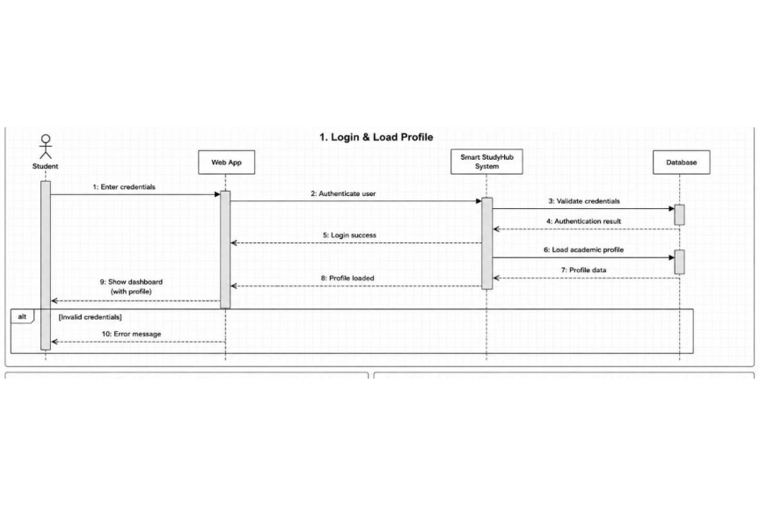
Figure 6.2.1 — Sequence Diagram: Login and Load Profile
The student submits credentials to the Web App, which forwards an authentication request to the Smart StudyHub System. The system validates credentials against the Database and returns an authentication result. Upon success, the student's profile is loaded and the dashboard is displayed. If credentials are invalid, an error message is returned to the student.

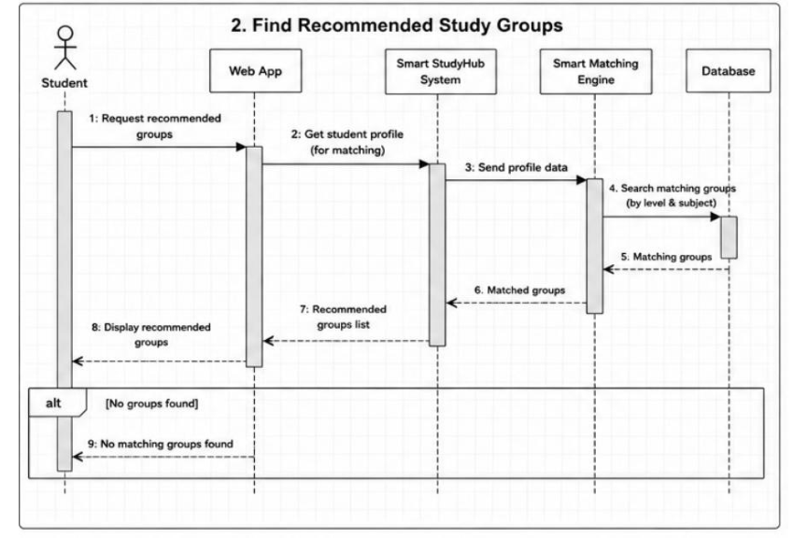
Figure 6.2.2 — Sequence Diagram: Find Recommended Study Groups
The student requests recommended groups. The Web App retrieves the student's profile and passes it to the Smart StudyHub System, which forwards it to the Smart Matching Engine. The engine queries the Database for compatible groups and returns the results. The matched groups are displayed to the student. If no groups exist, the system notifies the student accordingly.

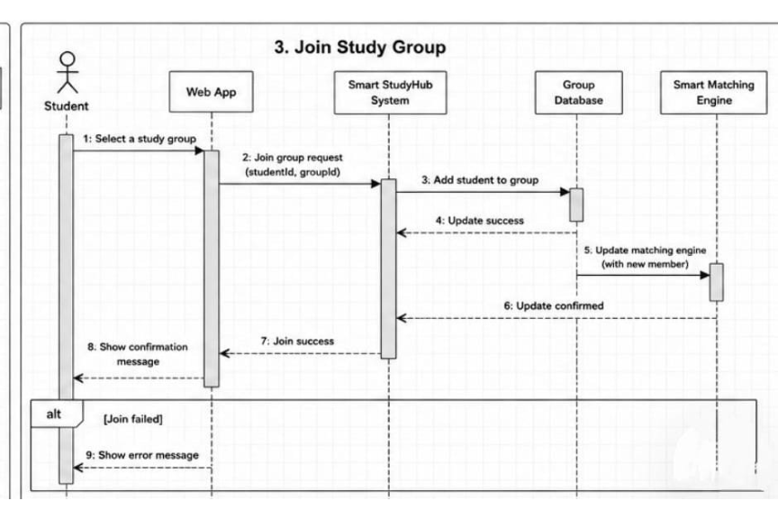
Figure 6.2.3 — Sequence Diagram: Join Study Group
The student selects a group and submits a join request. The system adds the student to the group in the Group Database and notifies the Smart Matching Engine of the new membership. A success confirmation is displayed. If the request fails (e.g., group is full), an error message is shown.

6.3 Activity Diagram
The Activity Diagram illustrates the overall workflow of the Smart StudyHub System, organised across four swim lanes: Student, System, Matcher, and Quiz Engine.

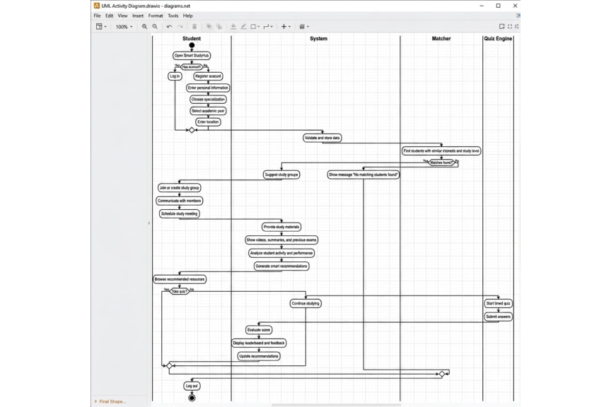
Figure 6.3 — Smart StudyHub System: Activity Diagram

The workflow starts when the student opens the platform. A decision node checks whether the student has an account — if yes, the student logs in; if no, the student registers by entering their information. After authentication, the System validates and stores the data while the Matcher searches for compatible peers. If matches are found, study groups are suggested; otherwise, a no-match message is shown. The student joins or creates a group, communicates with members, and schedules meetings. The System provides study materials and generates smart recommendations. The student then chooses to either continue studying or take a quiz. If a quiz is taken, the Quiz Engine starts a timed session and the student submits answers. The System evaluates the score, updates the leaderboard, and refreshes recommendations. The session ends with the student logging out.

6.4 Class Diagram
The Class Diagram shows the system's core classes, their attributes, methods, and relationships. It serves as the structural blueprint for the system's object-oriented design.

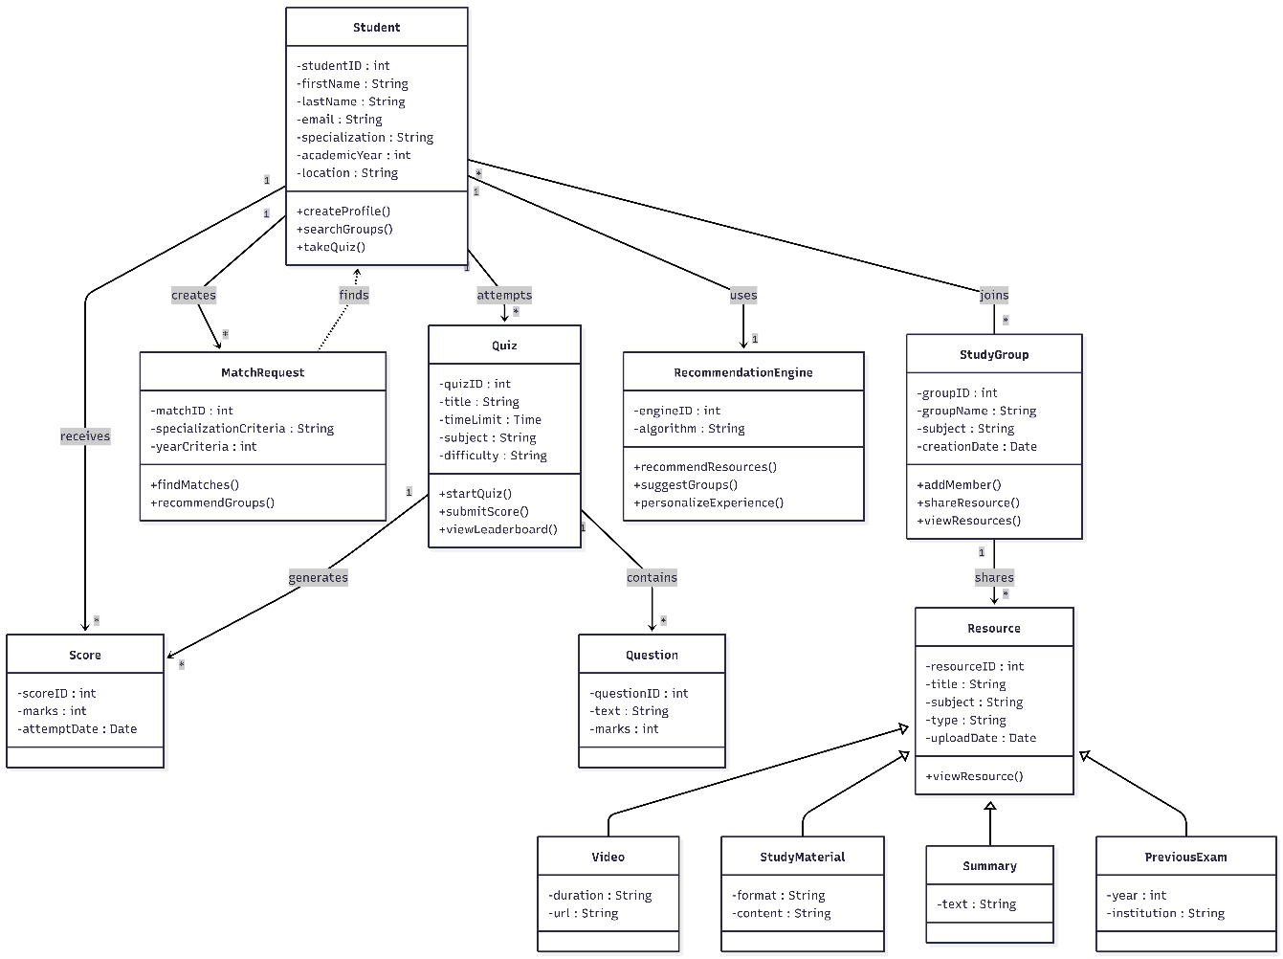
Figure 6.4 — Smart StudyHub System: Class Diagram

The Class Diagram represents the main classes and relationships in the Smart StudyHub System.
The Student class is the main entity in the system and includes attributes such as studentID, firstName, email, specialization, academicYear, and location. It provides functions like createProfile(), searchGroups(), and takeQuiz().
The Student interacts with MatchRequest, Quiz, RecommendationEngine, and StudyGroup classes. The MatchRequest class is responsible for finding suitable study partners based on specialization and academic year.
The Quiz class manages quizzes and contains Question objects, while the StudyGroup class manages study groups and shared resources.
The Resource class represents study materials and has subclasses including Video, StudyMaterial, Summary, and PreviousExam.
The RecommendationEngine class provides smart recommendations for resources and study groups based on student data and activity.

6.5 DFD Diagrams
The Data Flow Diagrams present a hierarchical decomposition of the system's data processing, from the context level down to detailed sub-process levels.

6.5.1 Context Level DFD

Figure 6.5.1 — Study Hub System: Context Level DFD
Shows the system as a single process (Process 0) interacting with the Student and Admin external entities. All system inputs and outputs are defined at this level.

6.5.2 Level 0 DFD — System Overview
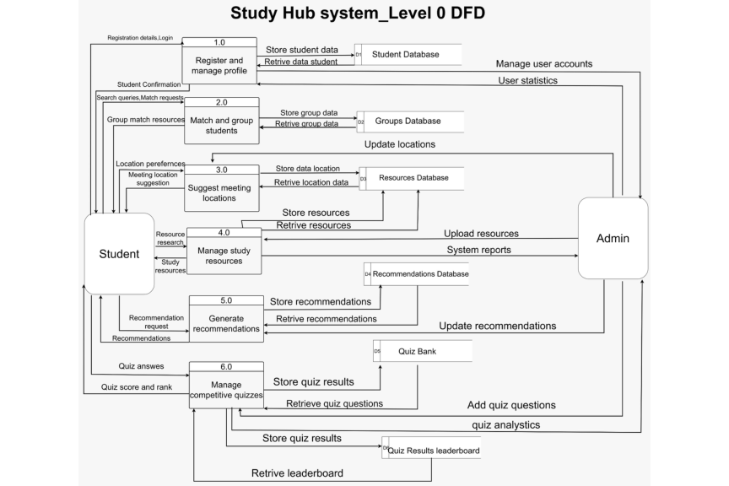
Figure 6.5.2 — Study Hub System: Level 0 DFD
Decomposes the system into six main processes: Register and Manage Profile (1.0), Match and Group Students (2.0), Suggest Meeting Locations (3.0), Manage Study Resources (4.0), Generate Recommendations (5.0), and Manage Competitive Quizzes (6.0). Each process is supported by one or more data stores including the Student Database (D1), Groups Database (D2), Resources Database (D3), Recommendations Database (D4), Quiz Bank (D5), and Quiz Results Leaderboard (D6).

6.5.3 Level 1 DFD — Register and Manage Profile (Process 1.0)
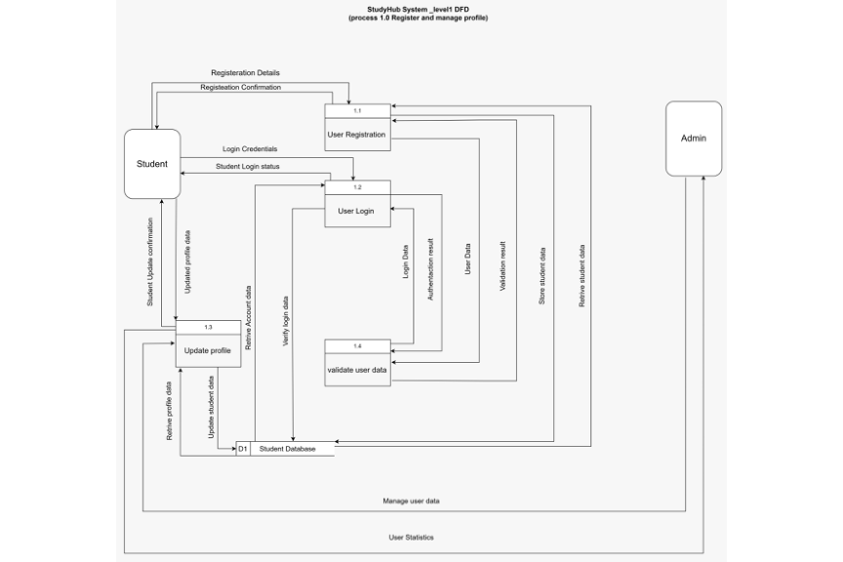
Figure 6.5.3 — StudyHub System: Level 1 DFD (Process 1.0)

Decomposes Process 1.0 into four sub-processes: User Registration (1.1), User Login (1.2), Update Profile (1.3), and Validate User Data (1.4). All sub-processes interact with the Student Database (D1). The Admin receives user statistics and manages accounts through this process group.

6.5.4 Level 2 DFD — User Registration (Process 1.1)
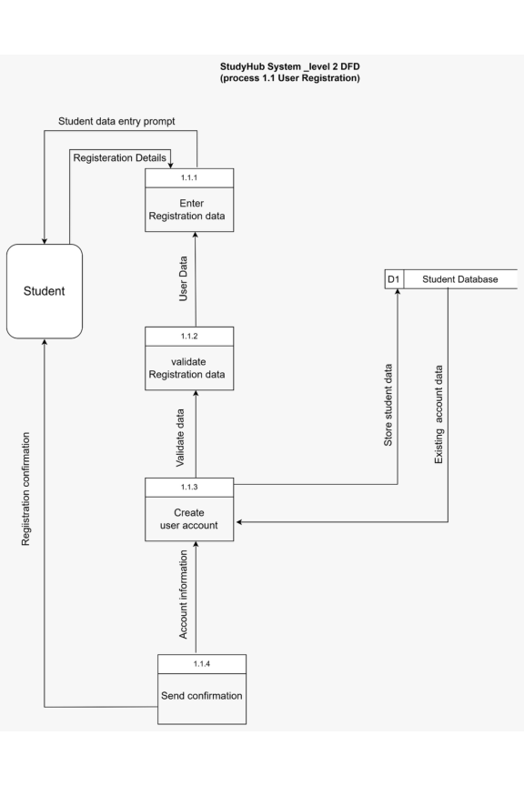
Figure 6.5.4 — StudyHub System: Level 2 DFD (Process 1.1)
Decomposes User Registration into: Enter Registration Data (1.1.1), Validate Registration Data (1.1.2), Create User Account (1.1.3), and Send Confirmation (1.1.4). Data passes sequentially through these sub-processes, with Process 1.1.3 checking the Student Database for duplicate accounts before creating a new entry.

6.5.5 Level 3 DFD — Validate Registration Data (Process 1.1.2)
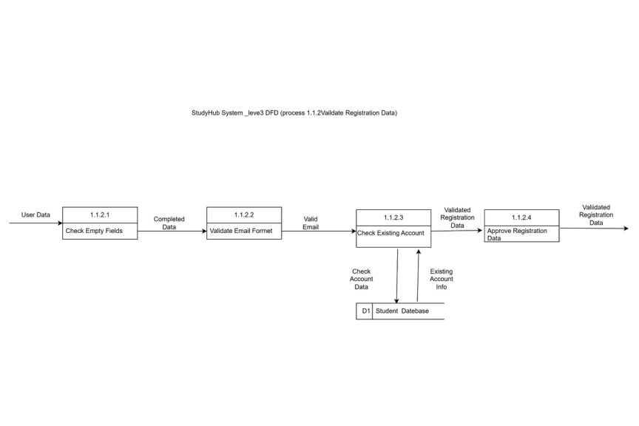
Figure 6.5.5 — StudyHub System: Level 3 DFD (Process 1.1.2)

This diagram focuses on the validation process during registration. It checks whether required
fields are completed, validates the email format, verifies account uniqueness, and approves
the registration data before account creation.

6.5.6 Level 4 DFD — Check Existing Account (Process 1.1.2.3)
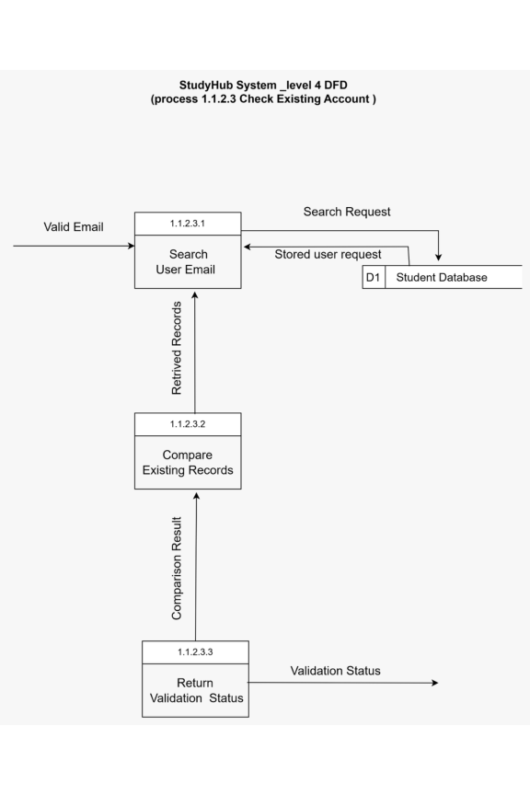
Figure 6.5.6 — StudyHub System: Level 4 DFD (Process 1.1.2.3)

This diagram explains how the system checks whether an account already exists. The entered
email is compared with stored records in the Student Database, and the system returns a
validation result indicating whether the account is valid or already registered.

6.5.7 Level 5 DFD — Check Email Field (Process 1.1.2.1.2)
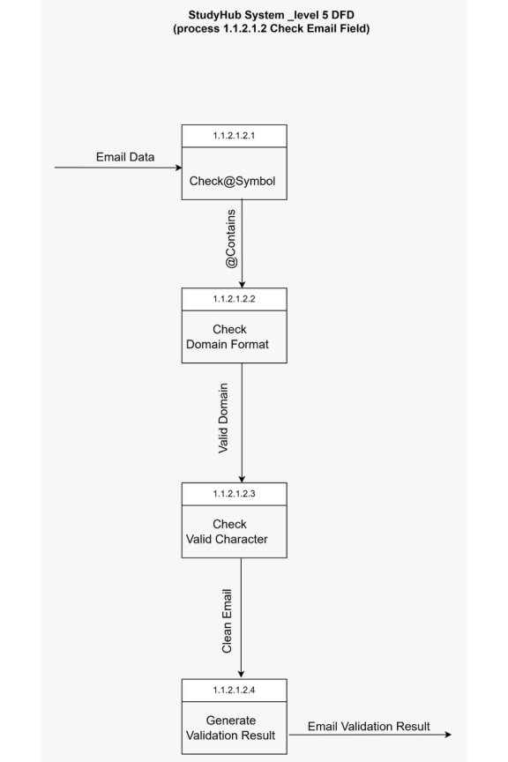
Figure 6.5.7 — StudyHub System: Level 5 DFD (Process 1.1.2.1.2)

This diagram illustrates the email validation process. The system checks the email structure,
verifies the domain format, validates allowed characters, and generates the final validation result.

6.5.8 Level 6 DFD — Check Email Domain (Process 1.1.2.1.2.2)
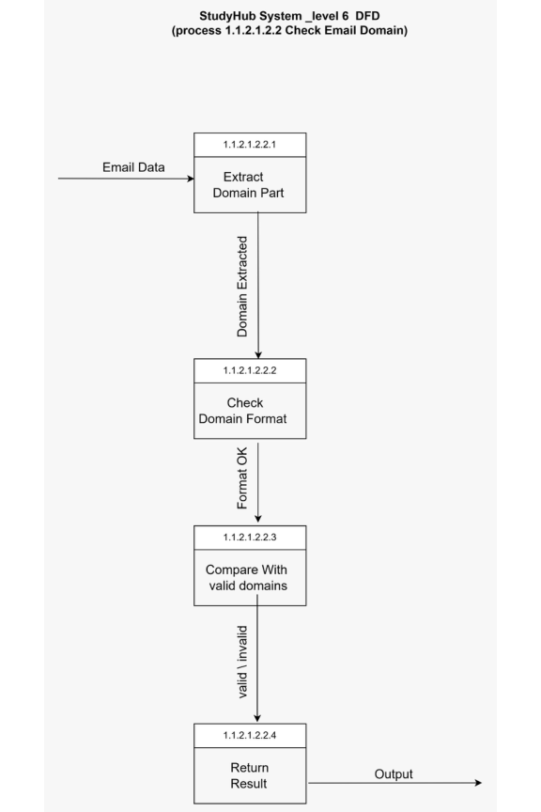
Figure 6.5.8 — StudyHub System: Level 6 DFD (Process 1.1.2.1.2.2)

This diagram represents the deepest level of email validation. It shows how the system
extracts the domain part of the email, validates its format, compares it with accepted
domains, and returns the final validation result.

